**Soyuz TMA-6**

From Wikipedia, the free encyclopedia

|  |  |
| --- | --- |
| **Soyuz TMA-6** | |
| **Mission insignia** | |
| **Mission statistics** | |
| **Mission name** | Soyuz TMA-6 |
| **Spacecraft mass** | 7,200 kg |
| **Crew size** | 3 |
| **Launch pad** | Gagarin's Start |
| **Launch date** | April 15, 2005 00:46:25 UTC |
| **Landing** | October 11, 2005 01:09:00 UTC |
| **Mission duration** | 179.984 days |
| **Number of orbits** | 2,817 |
| **Apogee** | 360 km |
| **Perigee** | 349 km |
| **Orbital period** | 92.6 minutes |
| **Orbital inclination** | 51.64° |
| **Related missions** | |
| |  |  | | --- | --- | | **Previous mission** | **Next mission** | | Soyuz TMA-5 | Soyuz TMA-7 | | |

**Soyuz TMA-6** was a Soyuz mission to the International Space Station (ISS) launched by a Soyuz-FG launch vehicle.

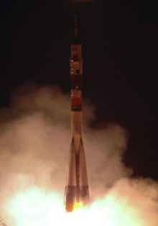

Soyuz TMA-6 launch

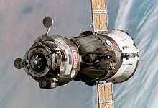

Soyuz TMA-6 approaching the International Space Station

**Crew**

**Launched and landed ISS *Expedition 11* crew**

* *Sergei Krikalev (6)* - Commander -  Russia



* *John Phillips (2)* - Flight Engineer 1 -  United States



**Launched**

* Roberto Vittori (2) - Flight Engineer 2 - ESA  Italy



**Landed**

* Gregory Olsen (1) - Spaceflight Participant -  United States



**Docking with ISS**

* **Docked to ISS:** April 17, 2005, 02:20 UTC (to Pirs module)
* **Undocked from ISS:** July 19, 2005, 10:38 UTC (from Pirs module)
* **Docked to ISS:** July 19, 2005, 11:08 UTC (to nadir port of Zarya)
* **Undocked from ISS:** October 10, 2005, 21:49 UTC (from nadir port of Zarya)

**Mission highlights**

26th manned flight to ISS.

**Soyuz TMA-6** is a Soyuz TMA spacecraft which was launched on April 15, 2005 by a Soyuz-FG rocket from Baikonur Cosmodrome.

During the return flight from the ISS instruments in the descent module of the Soyuz spacecraft indicated a cabin-pressure-leak that is still under investigation.

The Expedition 11 crew, Sergei Krikalev-Cdr Russia, John Phillips-U.S.A. replaced the Expedition 10 crew, Leroy Chiao-Cdr U.S.A. and Salizhan Sharipov-Russia.

This page was last modified on 20 December 2009 at 21:39.